Ministry of Industry Honorary Patron of the Congress INDUSTRY IN TRANSITION
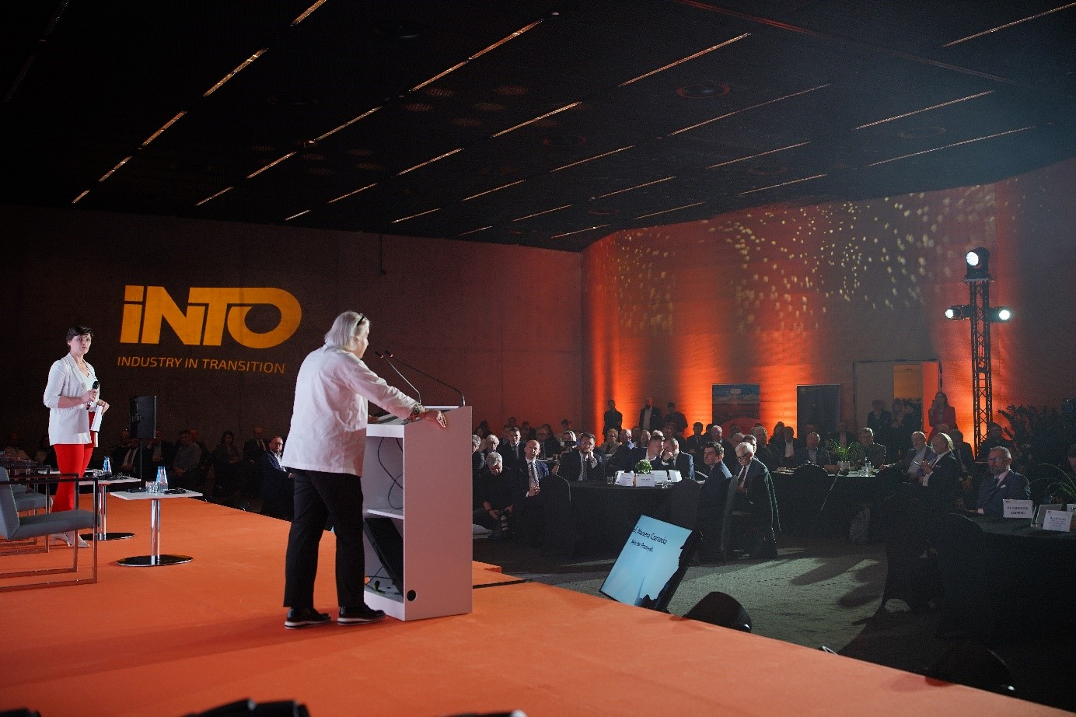
The Ministry of Industry has assumed honorary patronage of the European Congress of Industry and Energy INDUSTRY IN TRANSITION. Minister Marzena Czarnecka has declared her presence at the event.

- I don't need to be convinced how decisive business people, entrepreneurs are for successful economic as well as social development. I am fully aware that the energy and economic transformation, which is the subject of my mission at the Ministry of Industry, cannot succeed without the support of both large companies and strategic firms, as well as those smaller, but very numerous, from the sector of Small and Medium-sized Enterprises, craftsmen or traders. Since the first day in the building on Powstańców Street in Katowice, I have been trying to meet as often as possible with representatives of various groups and environments, precisely in order to directly learn about their opinions, assessments, pains, needs and demands - Marzena Czarnecka in response to a question about listening to the voice and opinion of small and medium-sized entrepreneurs, who drive the country's economic growth.

Registration for the event: HERE
Organizer: Chamber of Commerce and Industry in Katowice

